📌 1.2 Types of Web Services
(SOAP vs REST – Deep Understanding for API Testing)

🔵 A) SOAP (Simple Object Access Protocol)
SOAP is a protocol for exchanging structured information in web services.
It is:
- Strict
- Standardized
- XML-based
- Enterprise-oriented

🔹 1️⃣ XML Structure in SOAP
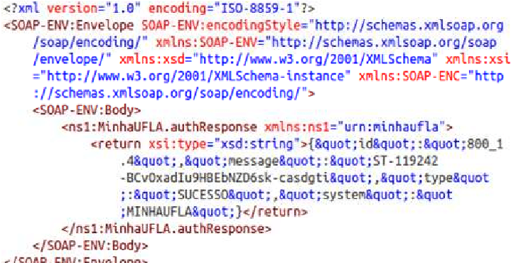
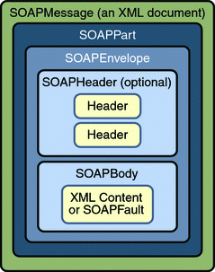
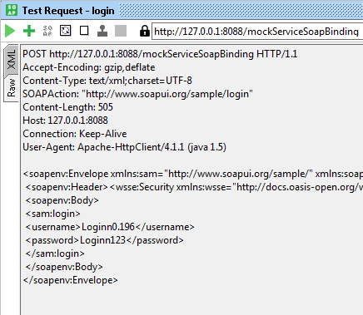
4
SOAP messages are always written in XML.
Example SOAP Request:
<soap:Envelope>
<soap:Header>
<auth>Token123</auth>
</soap:Header>
<soap:Body>
<getUser>
<id>101</id>
</getUser>
</soap:Body>
</soap:Envelope>
🔎 Structure Breakdown:
- Envelope → Root element (mandatory)
- Header → Metadata (security, tokens)
- Body → Actual request/response data
SOAP is very structured and strict.

🔹 2️⃣ WSDL (Web Services Description Language)
WSDL is:
A contract file that describes how to use the SOAP service.
It defines:
- Available operations
- Input/output parameters
- Data types
- Endpoint URL
Think of WSDL as:
📘 “API Documentation in machine-readable format”
Without WSDL → You cannot properly call SOAP APIs.

🔹 3️⃣ Envelope, Header, Body (Mandatory Structure)
SOAP message always has:
Envelope
├── Header (Optional but common)
└── Body (Mandatory)
Header Contains:
- Authentication info
- Digital signatures
- Transaction info
Body Contains:
- Business logic data
SOAP is very rigid — structure must be followed strictly.

🔹 4️⃣ WS-Security
SOAP supports enterprise-grade security:
- Digital signatures
- Encryption
- Identity verification
- Token validation
This makes SOAP suitable for:
- Banking
- Government
- Financial institutions
SOAP has built-in security standards.

🔹 5️⃣ SOAP Use Cases
SOAP is commonly used in:
- Banking systems
- Payment gateways
- Telecom systems
- Legacy enterprise systems
Why?
Because:
- Strong security
- Strict contract
- Transaction reliability

🟢 B) REST (Representational State Transfer)
REST is NOT a protocol.
It is an architectural style.
It is:
- Lightweight
- Flexible
- Fast
- Widely used in modern apps

🔹 1️⃣ Resource-Based Architecture
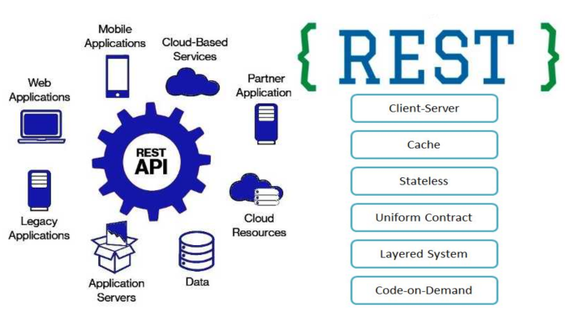
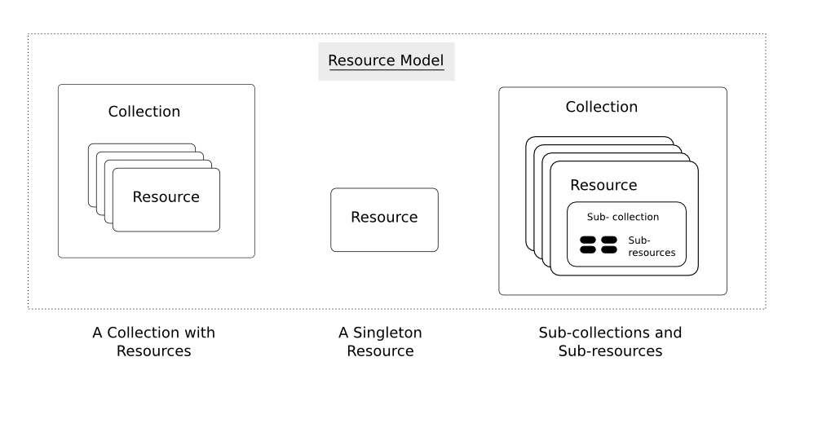
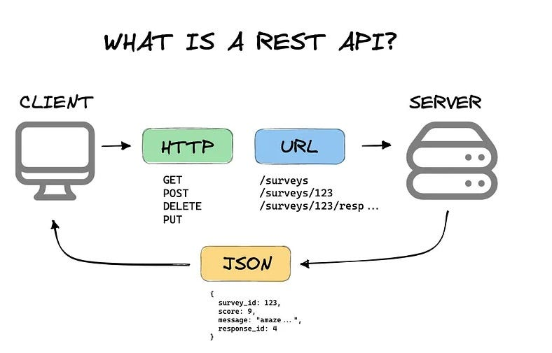
4
In REST:
Everything is treated as a resource.
Example resources:
- /users
- /orders
- /products
Operations are done using HTTP methods:
Method | Operation
GET | Read
POST | Create
PUT | Update
DELETE | Remove
REST focuses on resources, not actions.

🔹 2️⃣ URI Structure
A REST API has clean URIs:
Good REST URI:
GET /users/101
Bad REST URI:
GET /getUserById?id=101
REST best practice:
- Use nouns
- Use plural resources
- Use hierarchical structure
Example:
/users/101/orders

🔹 3️⃣ Data Formats
Unlike SOAP (only XML),
REST supports:
- JSON (most common)
- XML
- Plain text
- HTML
Most APIs today use JSON because:
- Lightweight
- Easy to read
- Faster parsing
Example REST Response:
{
"id": 101,
"name": "Lakshay",
"email": "lakshay@gmail.com"
}

🔹 4️⃣ Lightweight Communication
REST is:
- Faster than SOAP
- Uses standard HTTP
- No heavy XML parsing
- Less bandwidth consumption
That’s why:
✔ Mobile apps use REST
✔ Web apps use REST
✔ Microservices use REST

🧠 SOAP vs REST — Quick Comparison
Feature | SOAP | REST
Type | Protocol | Architectural Style
Data Format | Only XML | JSON, XML, etc.
Speed | Slower | Faster
Security | Built-in (WS-Security) | Token-based
Complexity | High | Simple
Use Case | Enterprise | Web & Mobile

🎯 From API Testing Perspective
As an API Tester:
You mostly test:
- REST APIs (90% of modern systems)
- JSON payloads
- Authentication tokens
SOAP testing is less common but still used in legacy systems.

🧪 Quick Understanding Check
1️⃣ Why is SOAP considered more secure than REST?
2️⃣ Why is REST preferred in microservices?
3️⃣ Which format consumes more bandwidth: XML or JSON? Why?
4️⃣ In REST, what makes an API “RESTful”?

